# Technical Task

Thank you for your interest in LiveScore Group and thank you in advance for completing this exercise. We don’t take the use of free time lightly, we really appreciate it. Please be prepared to share your thoughts on the below three questions in a presentation format. Please feel free to use any tools / approaches that you find necessary.

## New Customer Opt In

Below is a graph showing the email marketing opt in rate for customers who are new to the site. It is split by the type of device the user signed up on, App or Website. The yellow line represents the overall opt in rate (combination of app + web sign ups).

Please describe what is happening with the below graph.

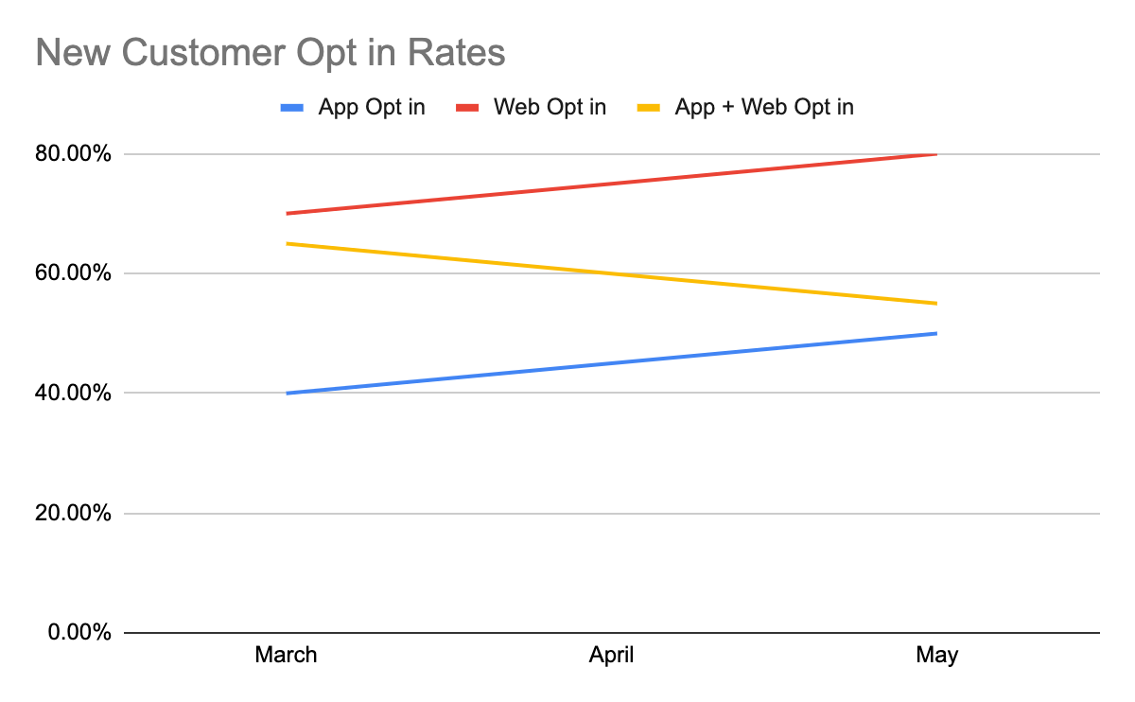

## Query Formatting

The below query is intended to work with the following tables.

|  |  |  |  |  |  |  |  |  |  |  |  |  |  |  |  |  |  |  |  |  |  |  |  |  |  |  |  |  |  |  |  |  |  |  |  |  |  |  |  |  |  |  |  |  |  |  |
| --- | --- | --- | --- | --- | --- | --- | --- | --- | --- | --- | --- | --- | --- | --- | --- | --- | --- | --- | --- | --- | --- | --- | --- | --- | --- | --- | --- | --- | --- | --- | --- | --- | --- | --- | --- | --- | --- | --- | --- | --- | --- | --- | --- | --- | --- | --- |
| |  |  | | --- | --- | | **USER** | | | **Column** | **Type** | | userID | VARCHAR | | firstName | VARCHAR | | lastName | VARCHAR | | brand | VARCHAR | | acquisitionDate | DATE | | |  |  | | --- | --- | | **BETS** | | | **Column** | **Type** | | betID | VARCHAR | | betSport | VARCHAR | | betAmount | INTEGER | | selectionTeam | VARCHAR | | betDate | DATE | | bettorID | VARCHAR | | |  |  | | --- | --- | | **CAMPAIGNS** | | | **Column** | **Type** | | CampaignID | VARCHAR | | UserID | INTEGER | | Channel | VARCHAR | | InteractionType | VARCHAR | | Timestamp | TIMESTAMP | |

**USER Table** - Holds all records relating to users across multiple brands.

**BETS Table** - Holds all betting records, bettorID acts as a foreign key to the USER table.

**CAMPAIGNS** **Table** - Holds records of marketing campaigns and user interactions with them. UserID acts as a foreign key to the USER table.

The following query attempts to answer the following questions, read through the query and amend it to SQL best practices.

* How many campaigns split by Marketing Channel did each LiveScore user receive in December 2022?
* How many bets did LiveScore users place on Football in December 2022?
* Identify LiveScore users that have previously bet on Basketball?
* Identify LiveScore users whose average stake (betAmount) was greater or equal to £10 over their lifetime.

Select u.userId, football_bets_count, channel, campaignsSent, previously_bet_on_basketball, average_stake

from table.USER u

left join (

SELECT bettorID,count(distinct betID) as football_bets_count

from table.BETS WHERE betSport = “Football” AND betDate between ‘2022-12-01’ and ‘2022-12-31’

GROUP BY 1,2

) f on u.userID = f.bettorID

LEFT JOIN (select userid, channel,,count(distinct campaignID) as campaignsSent

FROM table.CAMPAIGNS

WHERE interactionType = ‘sent’ and date_trunc(timestamp,month)=”2022-12-01”) c

on f.bettorID = c.userID

Left join (select bettorID, 1 as previously_bet_on_basketball

from table.BETS WHERE betSport = “Basketbal”) b on c.userID = b.bettorID

Left join (select bettorID, AVG(betAmount) as average_stake

from table.BETS GROUP by 1) a on b.bettorID = a.bettorID

Where brand = “LiveScore”

And average_stake >= 10

## Exploratory Analysis

We’ve just launched into a new territory, and you begin receiving the first data from our marketing campaigns. Explore the data provided in the LiveScore_Take_Home_Task.csv.zip file and carry out some initial analysis. You may take your analysis in any direction you like.

By virtue of the broad nature of the task and sample data you will have to make assumptions. Please ensure to document the assumptions you have made.